Relationship Between a Request and a REST API

🔹 What Is the Relationship Between a Request and a REST API?
# Source: Chatgpt (GPT-5-Mini) at [1/16/2026]
A REST API (Representational State Transfer API) is a way for clients and servers to communicate using HTTP requests and responses.
So, the request is the action the client performs, and the REST API defines the rules and structure for how that action is carried out.

✅ Relationship Explained:
# Source: Chatgpt (GPT-5-Mini) at [1/16/2026]
Concept | Explanation
Request | The message the client sends to ask for data or perform an action (e.g., create, read, update, delete).
REST API | A set of rules (architecture) that tells how requests should be structured and how the server should respond.
The request is how you interact with a REST API.

✅ Example of a REST API Request
# Source: Chatgpt (GPT-5-Mini) at [1/16/2026]
Let’s say there's a REST API for users:
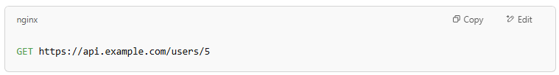
GET https://api.example.com/users/5
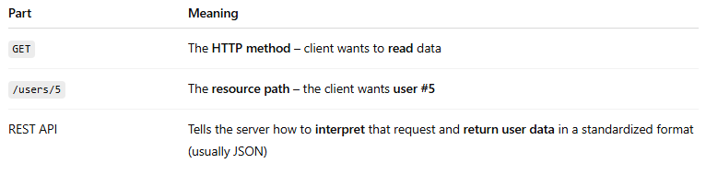

Part | Meaning
GET | The HTTP method – client wants to read data
/users/5 | The resource path – the client wants user #5
REST API | Tells the server how to interpret that request and return user data in a standardized format (usually JSON)

✅ Common HTTP Methods Used in REST APIs (Mapped to Actions)
# Source: Chatgpt (GPT-5-Mini) at [1/16/2026]
HTTP Method | Action | REST Meaning
GET | Read data | Retrieve a resource
POST | Create | Add a new resource
PUT | Update | Update an existing resource
DELETE | Remove | Delete a resource

🧠 Key Point:
# Source: Chatgpt (GPT-5-Mini) at [1/16/2026]
A request is how a client uses a REST API to access or change resources on the server.

✅ Summary:
# Source: Chatgpt (GPT-5-Mini) at [1/16/2026]
- A client request is the action.
- A REST API is the system that defines how that action should happen using HTTP.
- REST APIs use standard request types (GET, POST, etc.) and URLs to interact with resources.
Let me know if you want a working example using code like JavaScript or Python!

